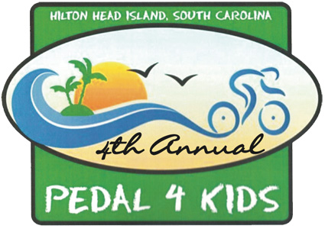
BOYS & GIRLS CLUB OF HILTON HEAD
PEDAL 4 KIDS-REGISTRATION FORM

Name ___________________________________________________________________________

Address _________________________________________________________________________

City _______________________________________ State _______________ Zip ______________

E-Mail ____________________________________ Phone _________________________________

( ) Individual Rider ( ) Team Rider

- Team Name ________________________________________________________________

- Team Captain Name__________________________________________________________

Registration includes: ride, T-shirt*, route maps, rider “goodie” bag, refreshments and lunch.
*T-shirts limited to first 400 riders who register.

Select Route ( ) Family Fun Ride ( ) 10 Mile ( ) 20/25 Mile ( ) 40 Mile-(Experienced Riders Only)

Adult Registration Fee $30 X ______________ $ ____________

Student Registration Fee (ages 6-22) $10 X ______________ $ ____________

Family Fun Ride (Kids 5 and under) FREE X ______________ $ 0.00________

*T-Shirt Size (s) #______ Small #_____ Medium # ______ Large #_____ X Large
Please mark t-shirt size.

Donation to support the Boys & Girls Club of Hilton Head $ ____________

Support-A-Child for One Year @ $365.00 $_____________

TOTAL AMOUNT ENCLOSED $_____________

Bike & Helmet Rentals are available for $10 by calling Hilton Head Bicycle Company @ 843-686-6888 (will deliver and pick up at Hilton Head High School on day of the event.). All proceeds will be donated to B&GC.

Form of Payment ( ) Check: Payable to: Boys & Girls Club of Hilton Head

Credit Card ( ) Visa ( ) MC ( ) AMEX ( ) ACTIVE.COM

Credit Card No _____________________________________________________________________

Exp Date __________________________ Security Code ___________________________________

Name on Card (Please Print)__________________________________________________________

Signature__________________________________________________________________________

Registration also available at www.active.com , or at www.bgchhi.org or by calling Hilton Head Boys and Girls Club at 843-689-3646

151 Gumtree Road • PO Box 22267 • Hilton Head Island SC 29925 • 843 689-3646 • www.bgchhi.org

BOYS & GIRLS CLUB OF HILTON HEAD
PEDAL 4 KIDS-WAIVER RELEASE FORM

□ I have read and agree to the following as a consideration of participation in the 2010 Pedal 4 Kids Bike Ride.
□ I realize that all registration fees are non refundable.
□ I will wear a helmet at all times while riding my bicycle during the ride.

I do hereby assume full responsibility for any and all damages, injuries (including death), or losses I may sustain or incur, if any, while attending, practicing, participating or witnessing in the Boys & Girls Club Pedal 4 Kids event. I hereby assume full risk, waive all claims and release and hold the Boys & Girls Club of Hilton Head Island and the Boys & Girls Club of the Lowcountry, its volunteers, employees or partners of said program or event, individually or otherwise, harmless for any and all claims for injuries and damages. I am fully aware and understand that the club does not employ or contract with any medical services or emergency medical services. I hereby release and covenant not to sue the club, directors, officers, employees, volunteers, representatives, agents, and lessees from any and all claims resulting from any physical injury that may occur to me or my child while participating in the Pedal 4 Kids event scheduled for September 25, 2010 which will take place on local paths and roadways of Hilton Head Island, South Carolina

□ I have fully read and fully understand the above release/waiver and fully understand that I have given up substantial rights by signing this waiver voluntarily.

Name (print) ______________________________________________________________

Email____________________________________________________________________

Signature ________________________________________________________________

Signature _________________________________________ Date ___________________
Guardian if under age of 18 years

Emergency Contact

Name/Relationship ______________________________Phone ______________________

151 Gumtree Road • PO Box 22267 • Hilton Head Island SC 29925 • 843 689-3646 • www.bgchhi.org

